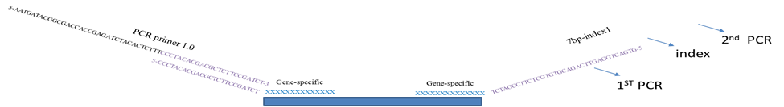

* 1st round of PCR reaction:

Forward primer(5’-3): CCCTACACGACGCTCTTCCGATCTN8XXXXXX

XXXXXX represents your forward primer for the target region

Reverse primer(5’-3): GTGACTGGAGTTCAGACGTGTGCTCTTCCGATCTN6YYYYYY

YYYYYY represents your reverse primer for the target region

After 1st round of PCR reaction, purify the PCR product.

* Index will be added during the second round PCR. Use ~10ng PCR product as the template for the 2nd round of PCR reaction:

Forward primer is the universal primer

AATGATACGGCGACCACCGAGATCTACACTCTTTCCCTACACGACGCTCTTCCGATC*T

(* means phosphothioate bond)

Reverse primer has the unique index, so each it will be different.

7bp-index1

CAAGCAGAAGACGGCATACGAGATcctgcgaGTGACTGGAGTTCAGACGTGTGCTCTTCCGATC*T

7bp-index2

CAAGCAGAAGACGGCATACGAGATtgcagagGTGACTGGAGTTCAGACGTGTGCTCTTCCGATC*T

Gecko library A and B sequencing primers:

* 1st round of PCR reaction:

Forward primer(5’-3):

**Gecko ill- seq F1 :** CCCTACACGACGCTCTTCCGATCTNNNNNNNNtcttgtggaaaggacgaaacaccg

xxxxxx represents your forward primer for the target region

Reverse primer(5’-3):

**Gecko ill- seq R1:** GTGACTGGAGTTCAGACGTGTGCTCTTCCGATCTNNNNNNTCTACTATTCTTTCCCCTGCACTGT

YYYYYY represents your reverse primer for the target region